Appendix

Emma Kaufman, Mark Lamendola, and Sarah Sussman

2024-10-02

### Data

The daily area weighted mean precipitation data used for these analyses came from USGS gauging stations in Boone, Greensboro, and Greenville. The HUC codes for each station are as follows:

* Boone HUC 050500010201
* Greensboro HUC 030300020105
* Greenville 030201030403

We used these data to analyze whether precipitation characteristics have changed for the different college campuses located in each of these cities since the last major investment in infrastructure that wrapped up in 1999.

We began our analysis by preparing the data to analyze different storm event durations, focusing on 24-hr and 72-hr storm events. To get estimates for 72-hr storm events we took a rolling sum across a 3 day window to get an estimated 72-hour storm event for each day. For 24-hr storm events we took a moving average of 24-hr data over a 7-day window to ensure each event being analyzed was statistically different from the others, which is an assumption of the Weibull recurrence interval calculation.

For the 24-hour data we then found monthly maximum 24 hour events for each month in each year of available data. The maximum 24-hour storm event for each month from 1980-2016 was then used to calculate recurrence intervals for 24-hour storm events.

We calculated both the Weibull and Hazen recurrence intervals for Boone, Greensboro, and Greenville’s monthly maximum 24-hour and 72-hour storm events from 1980-1999 and from 2000-2016. Recurrence intervals using each method differed due to Weibull being more conservative (assigning higher return periods for more extreme events), and Hazen being less conservative (assigning a smoother distribution of recurrence intervals). Due to the large sample size and wanting to have conservative estimates based on the application of using these return periods being used for flood mitigation, we moved forward with using Weibull return periods for our decision making process.

After calculating return intervals for each 24-hour and 72-hour storm event in each time frame of interest (pre- and post-2000) we plotted the difference in return periods from 1980-1999 and from 2000-2016 for each city.

Since 1980-1999, events of the same likelihood have become more intense. For example, in Boone, a 1 inch 24-hour event from 1980-1999 had a 37.5% chance of occurring. More recent data (2000-2016) shows that the same likelihood event would be associated with around a 1.25 in 24 hour event.

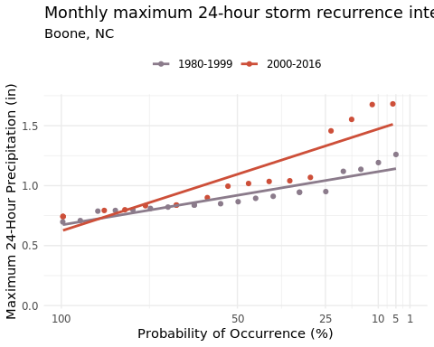

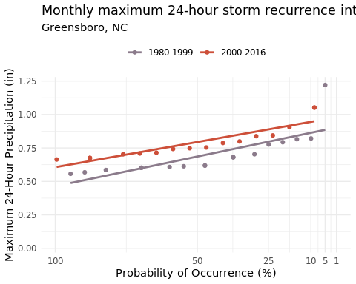

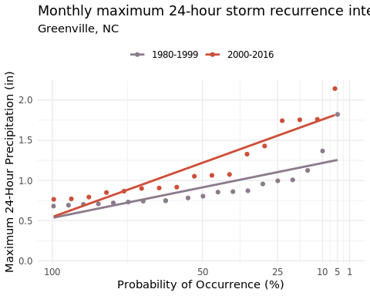

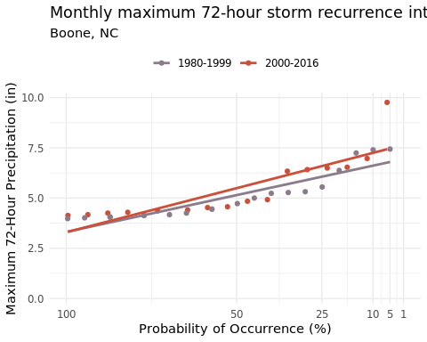

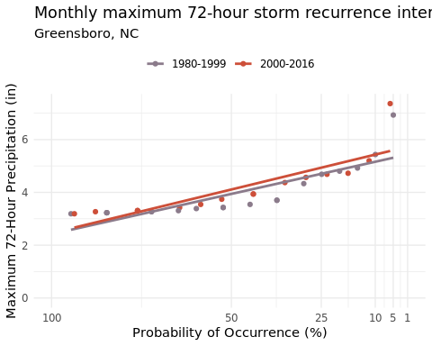

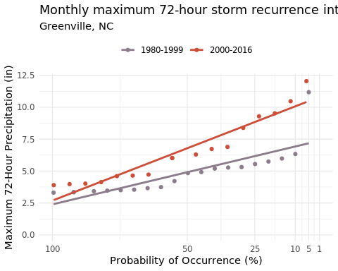

The lines of best fit on each of the above graphs represent the probability distributions of different intensity 24-hr and 72-hr storm events (range on y-axis) in 1980-1999 and 2000-2016. We used these probability distributions to extract the depth of precipitation for 10, 25, 50, and 100 year flood events for 24-hr and 72-hr events in each city for the two time periods, as seen in the tables below: Precipitation frequency estimates (in) for Boone, NC - 1980-1999

Precipitation frequency estimates (in) for Boone, NC - 1980-1999

| Duration | 10 Year Flood | 25 Year Flood | 50 Year Flood | 100 Year Flood |
| --- | --- | --- | --- | --- |
| 24-hr | 1.20 | 1.4 | 1.54 | 1.69 |
| 72-hr | 6.94 | 8.1 | 8.98 | 9.87 |

Precipitation frequency estimates (in) for Boone, NC - 2000-2016

Precipitation frequency estimates (in) for Boone, NC - 2000-2016

| Duration | 10 Year Flood | 25 Year Flood | 50 Year Flood | 100 Year Flood |
| --- | --- | --- | --- | --- |
| 24-hr | 1.46 | 1.70 | 1.89 | 2.08 |
| 72-hr | 7.44 | 8.71 | 9.66 | 10.62 |

Precipitation frequency estimates (in) for Greensboro, NC - 1980-1999

Precipitation frequency estimates (in) for Greensboro, NC - 1980-1999

| Duration | 10 Year Flood | 25 Year Flood | 50 Year Flood | 100 Year Flood |
| --- | --- | --- | --- | --- |
| 24-hr | 0.96 | 1.12 | 1.23 | 1.35 |
| 72-hr | 5.41 | 6.30 | 6.98 | 7.66 |

Precipitation frequency estimates (in) for Greensboro, NC - 2000-2016

Precipitation frequency estimates (in) for Greensboro, NC - 2000-2016

| Duration | 10 Year Flood | 25 Year Flood | 50 Year Flood | 100 Year Flood |
| --- | --- | --- | --- | --- |
| 24-hr | 1.08 | 1.25 | 1.39 | 1.52 |
| 72-hr | 5.56 | 6.50 | 7.20 | 7.91 |

Precipitation frequency estimates (in) for Greenville, NC - 1980-1999

## Table: Precipitation frequency estimates (in) for Greenville, NC - 1980-1999

## |Duration | 10 Year Flood| 25 Year Flood| 50 Year Flood| 100 Year Flood|

## |:——–|————-:|————-:|————-:|————–:|

## |24-hr | 1.2| 1.40| 1.56| 1.71|

## |72-hr | 6.5| 7.62| 8.46| 9.31|

## Precipitation frequency estimates (in) for Greenville, NC - 2000-2016

## Table: Precipitation frequency estimates (in) for Greenville, NC - 2000-2016

## |Duration | 10 Year Flood| 25 Year Flood| 50 Year Flood| 100 Year Flood|

|:——–|————-:|————-:|————-:|————–:| |24-hr | 1.55| 1.82| 2.03| 2.24| |72-hr | 8.69| 10.27| 11.46| 12.66|

##   
## Precipitation frequency estimates (in) for Boone, NC - 1980-1999   
##   
##   
## Table: Precipitation frequency estimates (in) for Boone, NC - 1980-1999  
##   
## |Duration | 10 Year Flood| 25 Year Flood| 50 Year Flood| 100 Year Flood|  
## |:--------|-------------:|-------------:|-------------:|--------------:|  
## |24-hr | 1.20| 1.4| 1.54| 1.69|  
## |72-hr | 6.94| 8.1| 8.98| 9.87|  
##   
## Precipitation frequency estimates (in) for Boone, NC - 2000-2016   
##   
##   
## Table: Precipitation frequency estimates (in) for Boone, NC - 2000-2016  
##   
## |Duration | 10 Year Flood| 25 Year Flood| 50 Year Flood| 100 Year Flood|  
## |:--------|-------------:|-------------:|-------------:|--------------:|  
## |24-hr | 1.46| 1.70| 1.89| 2.08|  
## |72-hr | 7.44| 8.71| 9.66| 10.62|

##   
## Precipitation frequency estimates (in) for Greensboro, NC - 1980-1999   
##   
##   
## Table: Precipitation frequency estimates (in) for Greensboro, NC - 1980-1999  
##   
## |Duration | 10 Year Flood| 25 Year Flood| 50 Year Flood| 100 Year Flood|  
## |:--------|-------------:|-------------:|-------------:|--------------:|  
## |24-hr | 0.96| 1.12| 1.23| 1.35|  
## |72-hr | 5.41| 6.30| 6.98| 7.66|  
##   
## Precipitation frequency estimates (in) for Greensboro, NC - 2000-2016   
##   
##   
## Table: Precipitation frequency estimates (in) for Greensboro, NC - 2000-2016  
##   
## |Duration | 10 Year Flood| 25 Year Flood| 50 Year Flood| 100 Year Flood|  
## |:--------|-------------:|-------------:|-------------:|--------------:|  
## |24-hr | 1.08| 1.25| 1.39| 1.52|  
## |72-hr | 5.56| 6.50| 7.20| 7.91|

##   
## Precipitation frequency estimates (in) for Greenville, NC - 1980-1999   
##   
##   
## Table: Precipitation frequency estimates (in) for Greenville, NC - 1980-1999  
##   
## |Duration | 10 Year Flood| 25 Year Flood| 50 Year Flood| 100 Year Flood|  
## |:--------|-------------:|-------------:|-------------:|--------------:|  
## |24-hr | 1.2| 1.40| 1.56| 1.71|  
## |72-hr | 6.5| 7.62| 8.46| 9.31|  
##   
## Precipitation frequency estimates (in) for Greenville, NC - 2000-2016   
##   
##   
## Table: Precipitation frequency estimates (in) for Greenville, NC - 2000-2016  
##   
## |Duration | 10 Year Flood| 25 Year Flood| 50 Year Flood| 100 Year Flood|  
## |:--------|-------------:|-------------:|-------------:|--------------:|  
## |24-hr | 1.55| 1.82| 2.03| 2.24|  
## |72-hr | 8.69| 10.27| 11.46| 12.66|

[add explanation if anything is changing?] After getting the precipitation frequency estimates for 24-hr and 72-hr events for 10 year, 25 year, 50 year, and 100 year return intervals, we examined what the maximum monthly 24-hr and 72-hr events were from 1980-1999 and from 2000-2016 in each city. The purpose of this was to see if 25 year flood events (what we are assuming the infrastructure was designed for at each campus in 1999) are becoming more frequent or changing seasons. We counted how many times the maximum 24-hr and 72-hr flood events were occurring in each month pre-2000 and post-2000. We found

#Boone 24 hr  
prob_4_percent_value <- final_results_boone_24 %>%  
 filter(Timeframe == '1980-1999', Probability == 4) %>%  
 pull(Predicted_Precipitation_mm)  
  
boone_monthly_new_data <- Boone_24hr_monthlyavg %>%   
 filter(Timeframe=='2000-2016') %>%   
 group_by(month) %>%   
 summarise(avg=mean(max_24_mm),  
 max=max(max_24_mm),  
 exceed_count = sum(max_24_mm > prob_4_percent_value)) %>%   
   
 ungroup()  
  
boone_monthly_old_data <- Boone_24hr_monthlyavg %>%   
 filter(Timeframe=='1980-1999') %>%   
 group_by(month) %>%   
 summarise(avg=mean(max_24_mm),  
 max=max(max_24_mm),  
 exceed_count = sum(max_24_mm > prob_4_percent_value)) %>%   
 ungroup()

#Greensboro 24 hr  
prob_4_percent_value <- final_results_greensboro_24 %>%  
 filter(Timeframe == '1980-1999', Probability == 4) %>%  
 pull(Predicted_Precipitation_mm)  
  
greensboro_monthly_new_data <- Greensboro_24hr_monthlyavg %>%   
 filter(Timeframe=='2000-2016') %>%   
 group_by(month) %>%   
 summarise(avg=mean(max_24_mm),  
 max=max(max_24_mm),  
 exceed_count = sum(max_24_mm > prob_4_percent_value)) %>%   
   
 ungroup()  
  
greensboro_monthly_old_data <- Greensboro_24hr_monthlyavg %>%   
 filter(Timeframe=='1980-1999') %>%   
 group_by(month) %>%   
 summarise(avg=mean(max_24_mm),  
 max=max(max_24_mm),  
 exceed_count = sum(max_24_mm > prob_4_percent_value)) %>%   
 ungroup()

#Greenville 24 hour events:  
prob_4_percent_value <- final_results_greenville_24 %>%  
 filter(Timeframe == '1980-1999', Probability == 4) %>%  
 pull(Predicted_Precipitation_mm)  
  
greenville_monthly_new_data <- Greenville_24hr_monthlyavg %>%   
 filter(Timeframe=='2000-2016') %>%   
 group_by(month) %>%   
 summarise(avg=mean(max_24_mm),  
 max=max(max_24_mm),  
 exceed_count = sum(max_24_mm > prob_4_percent_value)) %>%   
   
 ungroup()  
  
greenville_monthly_old_data <- Greenville_24hr_monthlyavg %>%   
 filter(Timeframe=='1980-1999') %>%   
 group_by(month) %>%   
 summarise(avg=mean(max_24_mm),  
 max=max(max_24_mm),  
 exceed_count = sum(max_24_mm > prob_4_percent_value)) %>%   
 ungroup()

#Boone 72 hour  
prob_4_percent_value <- final_results_boone_72 %>%  
 filter(Timeframe == '1980-1999', Probability == 4) %>%  
 pull(Predicted_Precipitation_mm)  
  
boone_monthly_new_data_72 <- Boone_72hr_monthlyavg %>%   
 filter(Timeframe=='2000-2016') %>%   
 group_by(month) %>%   
 summarise(avg=mean(max_72hr_mm),  
 max=max(max_72hr_mm),  
 exceed_count = sum(max_72hr_mm > prob_4_percent_value)) %>%   
 ungroup()  
  
boone_monthly_old_data_72 <- Boone_72hr_monthlyavg %>%   
 filter(Timeframe=='1980-1999') %>%   
 group_by(month) %>%   
 summarise(avg=mean(max_72hr_mm),  
 max=max(max_72hr_mm),  
 exceed_count = sum(max_72hr_mm > prob_4_percent_value)) %>%   
 ungroup()

# Greensboro 72hr storm events  
prob_4_percent_value <- final_results_greensboro_72 %>%  
 filter(Timeframe == '1980-1999', Probability == 4) %>%  
 pull(Predicted_Precipitation_mm)  
  
greensboro_monthly_new_data_72 <- Greensboro_72hr_monthlyavg %>%   
 filter(Timeframe=='2000-2016') %>%   
 group_by(month) %>%   
 summarise(avg=mean(max_72hr_mm),  
 max=max(max_72hr_mm),  
 exceed_count = sum(max_72hr_mm > prob_4_percent_value)) %>%   
 ungroup()  
  
greensboro_monthly_old_data_72 <- Greensboro_72hr_monthlyavg %>%   
 filter(Timeframe=='1980-1999') %>%   
 group_by(month) %>%   
 summarise(avg=mean(max_72hr_mm),  
 max=max(max_72hr_mm),  
 exceed_count = sum(max_72hr_mm > prob_4_percent_value)) %>%   
 ungroup()

# Greenville 72hr storm events  
prob_4_percent_value <- final_results_greenville_72 %>%  
 filter(Timeframe == '1980-1999', Probability == 4) %>%  
 pull(Predicted_Precipitation_mm)  
  
greenville_monthly_new_data_72 <- Greenville_72hr_monthlyavg %>%   
 filter(Timeframe=='2000-2016') %>%   
 group_by(month) %>%   
 summarise(avg=mean(max_72hr_mm),  
 max=max(max_72hr_mm),  
 exceed_count = sum(max_72hr_mm > prob_4_percent_value)) %>%   
 ungroup()  
  
greenville_monthly_old_data_72 <- Greenville_72hr_monthlyavg %>%   
 filter(Timeframe=='1980-1999') %>%   
 group_by(month) %>%   
 summarise(avg=mean(max_72hr_mm),  
 max=max(max_72hr_mm),  
 exceed_count = sum(max_72hr_mm > prob_4_percent_value)) %>%   
 ungroup()

greensboro_explore_hurricane_pre <- Greensboro_24hr %>%   
 filter(year< 2000 & year > 1984,  
 `Area Weighted Mean Precipitation (mm per day)`> 24.4,  
 month== c(7,8,9,10))

## Warning: There was 1 warning in `filter()`.  
## ℹ In argument: `month == c(7, 8, 9, 10)`.  
## Caused by warning in `month == c(7, 8, 9, 10)`:  
## ! longer object length is not a multiple of shorter object length

#frequency of events greater than 10 year floods is the same  
#magnitude of those events is decreasing   
greensboro_explore_frontal_pre <-Greensboro_24hr %>%   
 filter(year< 2000,  
 `Area Weighted Mean Precipitation (mm per day)`> 24.4,  
 month== c(1,2,3,4,5,6))

## Warning: There was 1 warning in `filter()`.  
## ℹ In argument: `month == c(1, 2, 3, 4, 5, 6)`.  
## Caused by warning in `month == c(1, 2, 3, 4, 5, 6)`:  
## ! longer object length is not a multiple of shorter object length

greensboro_explore_hurricane_post <- Greensboro_24hr %>%   
 filter(year>= 2000,  
 `Area Weighted Mean Precipitation (mm per day)`> 24.4,  
 month== c(7,8,9,10))

## Warning: There was 1 warning in `filter()`.  
## ℹ In argument: `month == c(7, 8, 9, 10)`.  
## Caused by warning in `month == c(7, 8, 9, 10)`:  
## ! longer object length is not a multiple of shorter object length

greensboro_explore_frontal_post <-Greensboro_24hr %>%   
 filter(year>= 2000,  
 `Area Weighted Mean Precipitation (mm per day)`> 24.4,  
 month== c(1,2,3,4,5,6))

## Warning: There was 1 warning in `filter()`.  
## ℹ In argument: `month == c(1, 2, 3, 4, 5, 6)`.  
## Caused by warning in `month == c(1, 2, 3, 4, 5, 6)`:  
## ! longer object length is not a multiple of shorter object length

mean(greensboro_explore_hurricane_pre$`Area Weighted Mean Precipitation (mm per day)`)

## [1] 36.64706

mean(greensboro_explore_hurricane_post$`Area Weighted Mean Precipitation (mm per day)`)

## [1] 35.21053

mean(greensboro_explore_frontal_pre$`Area Weighted Mean Precipitation (mm per day)`)

## [1] 32.63636

mean(greensboro_explore_frontal_post$`Area Weighted Mean Precipitation (mm per day)`)

## [1] 30.63636

## Sources

Boone HUC 050500010201 Greensboro HUC 030300020105 Greenville 030201030403